**Course Specialist Year 12 Test Two 2022**

Student name: ________________ Teacher name: ________________

**Task type: Response**

**Time allowed for this task: _____40______ mins**

**Number of questions: _____6______**

**Materials required:** Upto 3Calculators with CAS capability (to be provided by the student)

Standard items: Pens (blue/black preferred), pencils (including coloured), sharpener, correction fluid/tape, eraser, ruler, highlighters

Special items: Drawing instruments, templates, notes on one unfolded sheet of   
A4 paper, and up to three calculators approved for use in the WACE examinations

**Marks available: __41____ marks**

**Task weighting: _10___%**

**Formula sheet provided: Yes**

**Note: All part questions worth more than 2 marks require working to obtain full marks.**

Q1 (2, 3 & 3= 8 marks)

Consider the functions  and 

1. Determine the natural domains of .

|  |
| --- |
| **Solution** |
|  |
| **Specific behaviours** |
| 🗸 domain of f  🗸 domain of g |

1. Does  exist over the natural domain of ? Explain.

|  |
| --- |
| **Solution** |
|  |
| **Specific behaviours** |
| 🗸 states range of g  🗸 states condition necessary to exist  🗸 shows that does not exist with actual subsets  Note: zero marks for not exist with no reasoning |

1. State the rule and largest possible domain for and its corresponding range.

|  |
| --- |
| **Solution** |
|  |
| **Specific behaviours** |
| 🗸 states rule  🗸 states largest domain  🗸 states range |

Q2 (2, 4, 1 & 3 = 10 marks)

The function  is defined below for .

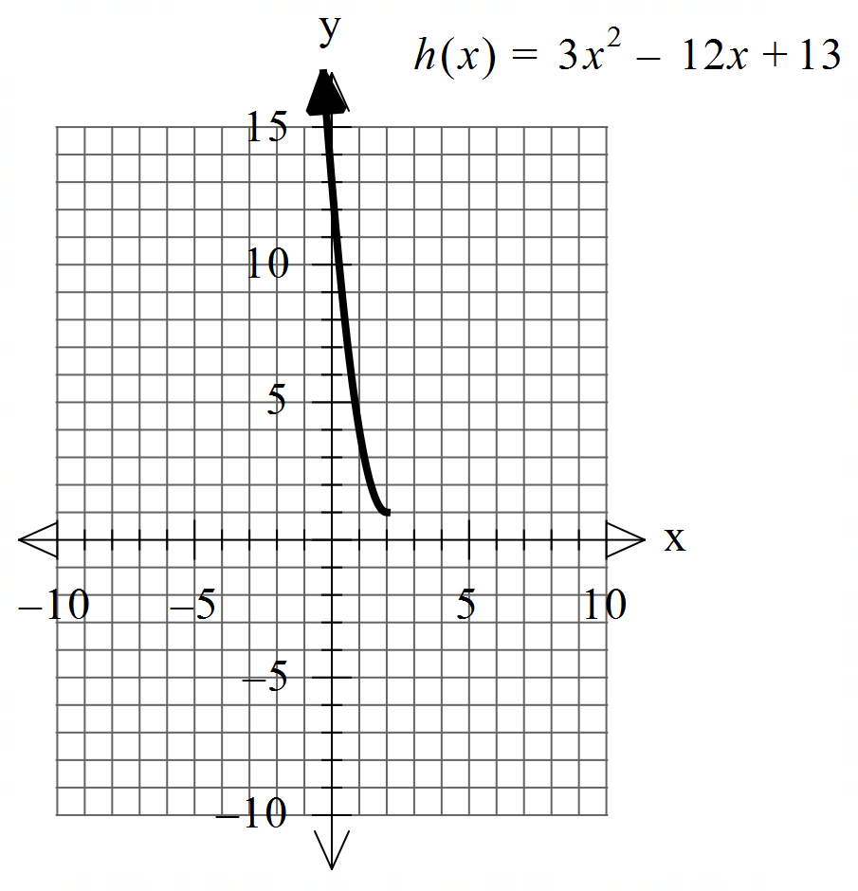

1. Sketch the inverse function  on the axes above.

|  |
| --- |
| **Solution** |
|  |
| **Specific behaviours** |
| 🗸 endpoint (1,2)  🗸 appears to be reflected in y=x, no need for dotted line |

Q2 continued

1. Determine the rule for and its domain showing **full working**.

|  |
| --- |
| **Solution** |
|  |
| **Specific behaviours** |
| 🗸 states domain of inverse  🗸 shows x & y interchanged or solving for x in original function  🗸 shows two possibilities for rule  🗸 discards the positive root  Note : max 2 out of 4 if no working |

1. Determine .

|  |
| --- |
| **Solution** |
|  |
| **Specific behaviours** |
| 🗸 states x |

1. Determine the exact coordinates (if any) for where .

|  |
| --- |
| **Solution** |
|  |
| **Specific behaviours** |
| 🗸 equates to x  🗸 solves for two x values  🗸 discards larger and give y coordinate |

Q3 (2 & 3 = 5 marks)

Consider the function  which is plotted below.

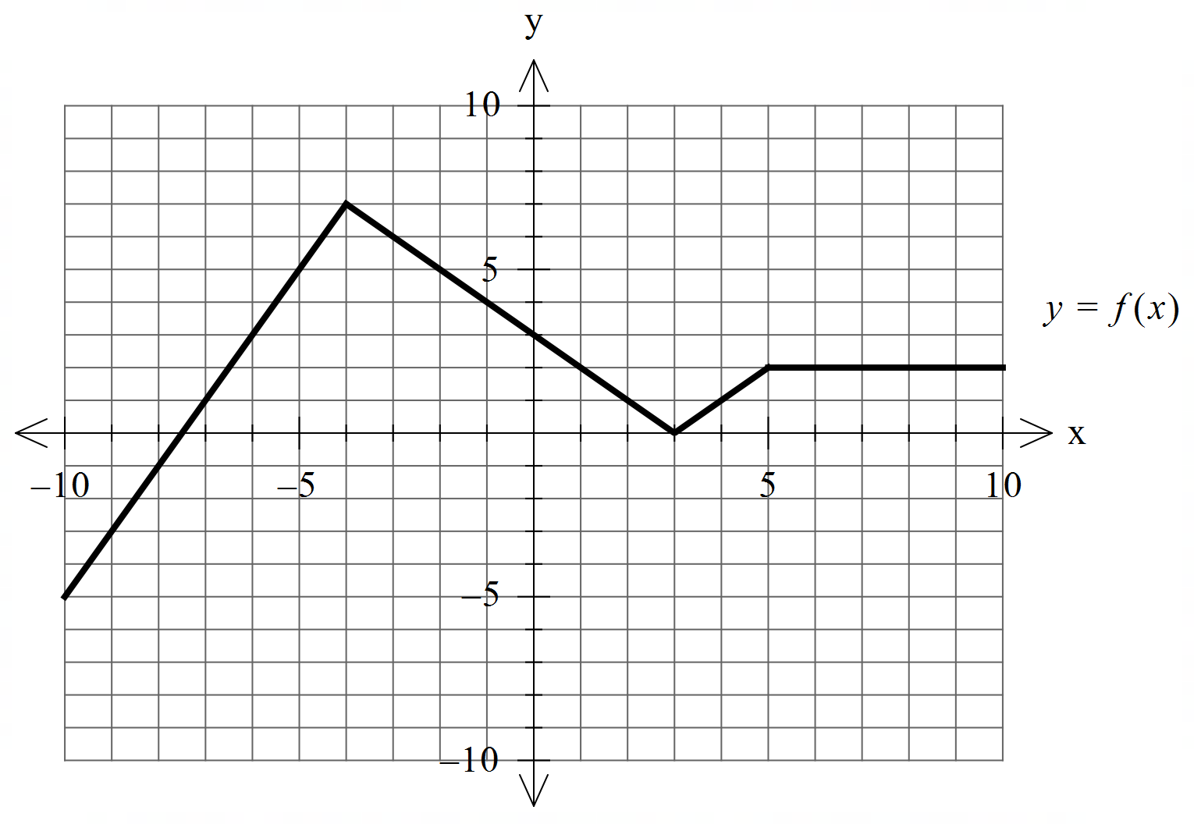



1. Sketch 

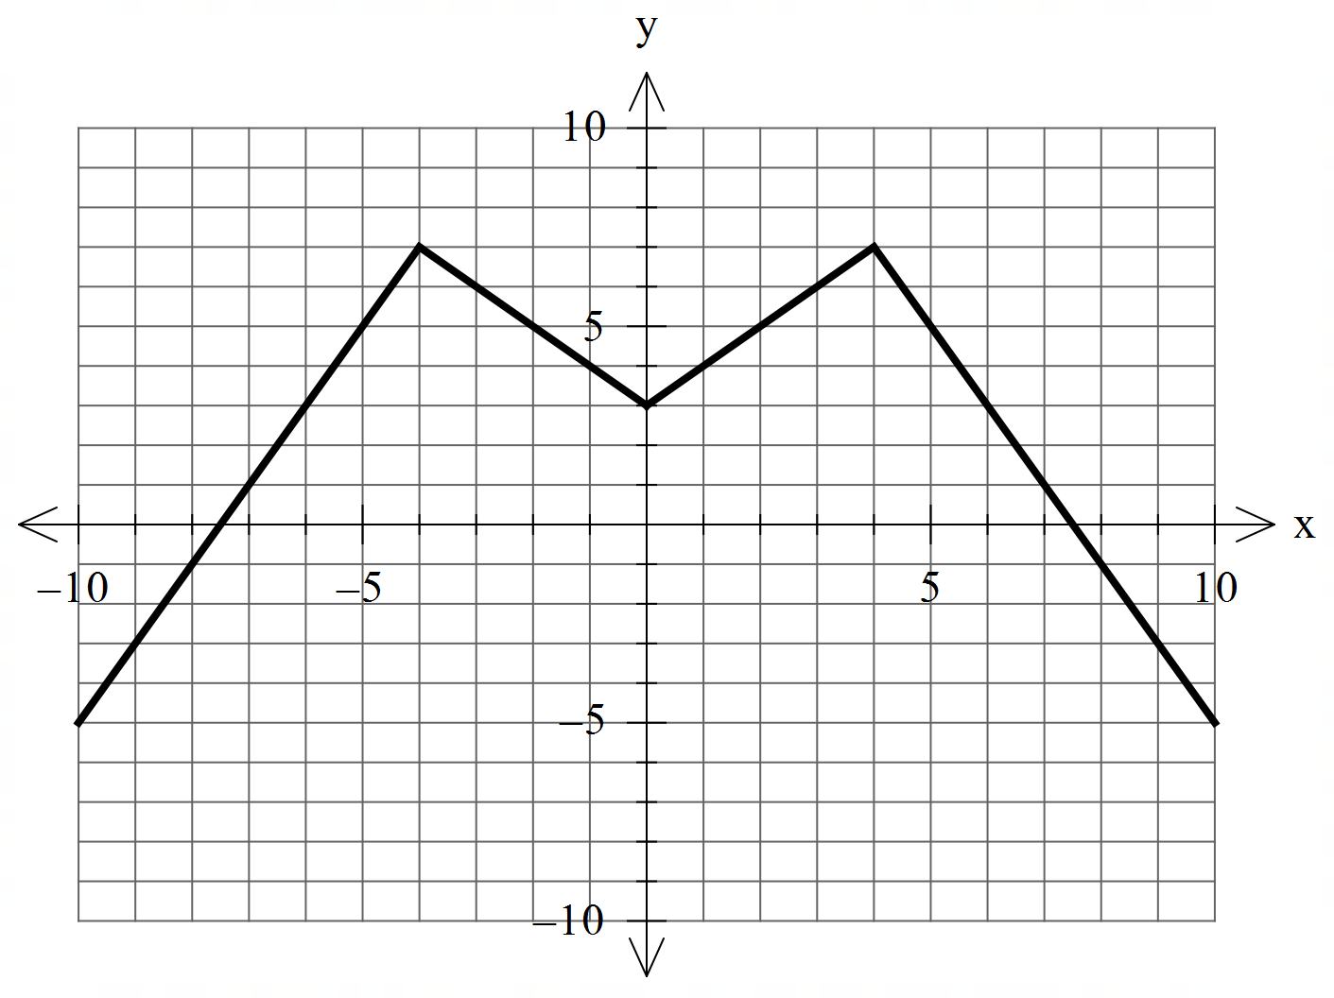

|  |
| --- |
| **Solution** |
|  |
| **Specific behaviours** |
| 🗸 reflects left side  🗸 x & y intercepts accurate |

b) Sketch 

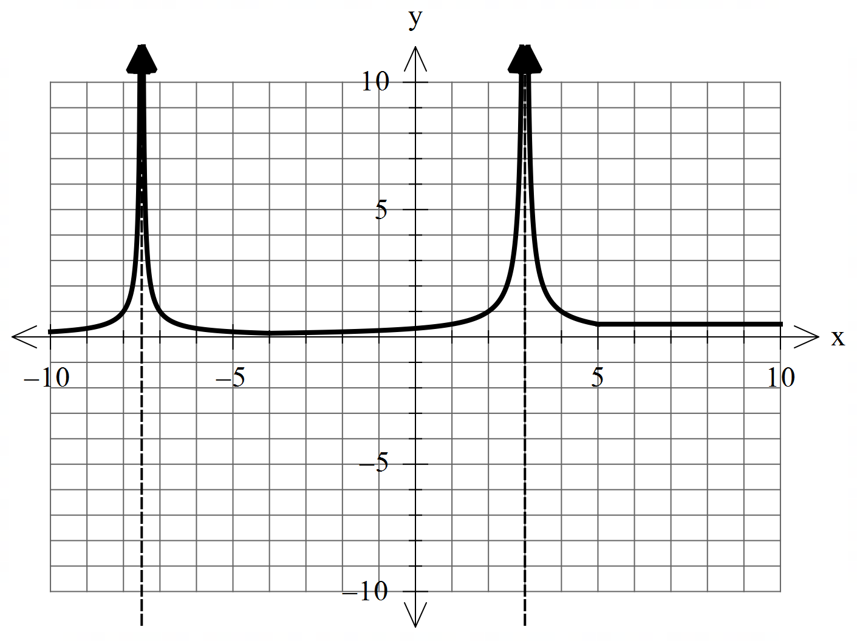

|  |
| --- |
| **Solution** |
|  |
| **Specific behaviours** |
| 🗸 two vertical asymptotes at correct positions  🗸 shape correct between asymptotes  🗸 y=0.5 for x>5 |

Q4 (4 marks)

Consider two moving objects A & B such that at  seconds  metres and metres per second. Determine the closet approach using **vector** methods.

|  |
| --- |
| **Solution** |
|  |
| **Specific behaviours** |
| 🗸 uses dot product  🗸 solves for time of closest approach  🗸 determines separation vector d  🗸 determines closest approach (approx.) |

Q5 (6 marks)

Consider a sphere  with  a constant and the line .

Determine all possible real values of such that:

1. the line meets the sphere at two pints.
2. the line is a tangent to the sphere.
3. the line misses the sphere completely.

|  |
| --- |
| **Solution** |
| |  |  | | --- | --- | |  |  | |
| **Specific behaviours** |
| 🗸 sets up an equation with both unknows  🗸 sets up a quadratic equation  🗸 obtains expression for discriminant  🗸 graphs discriminant or solves equalling zero  🗸 solves for tangent  🗸 solves for all 3 scenarios |

Q6 (2, 3 & 3 = 8 marks)

Consider the plane  given by .

1. The point  is on a plane parallel to . Determine the cartesian equation of this plane.

|  |
| --- |
| **Solution** |
|  |
| **Specific behaviours** |
| 🗸 identifies normal  🗸 states cartesian |

1. Determine the distance between these two planes. Show full reasoning.

|  |
| --- |
| **Solution** |
|  |
| **Specific behaviours** |
| 🗸 uses dot product  🗸 sets up expression for distance or subs line into vector plane equation  🗸 solves for distance, accept approx.  Note- formula used with derivation max 1 out of 3 |

1. Consider the lines  and . Determine the distance between these lines.

|  |
| --- |
| **Solution** |
|  |
| **Specific behaviours** |
| 🗸 determines normal vector to both planes  🗸 uses dot product with normal  🗸 determines approx. distance  Note: zero marks if closest approach method is used |

Extra working space